

Semester One Examination, 2018

Question/Answer booklet

Yr 12 SPECIALIST
UNIT 3

Section Two:

Calculator-assumed

Marking Key

Time allowed for this section
Reading time before commencing work: ten minutes
Working time: one hundred minutes

Materials required/recommended for this section
To be provided by the supervisor
This Question/Answer booklet
Formula sheet (retained from Section One)

To be provided by the candidate
Standard items: pens (blue/black preferred), pencils (including coloured), sharpener, correction fluid/tape, eraser, ruler, highlighters

Special items: drawing instruments, templates, notes on two unfolded sheets of A4 paper, and up to three calculators approved for use in this examination

Important note to candidates
No other items may be taken into the examination room. It is your responsibility to ensure that you do not have any unauthorised material. If you have any unauthorised material with you, hand it to the supervisor before reading any further.

Structure of this paper

Section | Number of questions available | Number of questions to be answered | Working time (minutes) | Marks available | Percentage of examination
Section One:  Calculator-free | 8 | 8 | 50 | 50 | 35
Section Two:  Calculator-assumed | 21 | 21 | 100 | 95 | 65
 |  |  |  | Total | 100

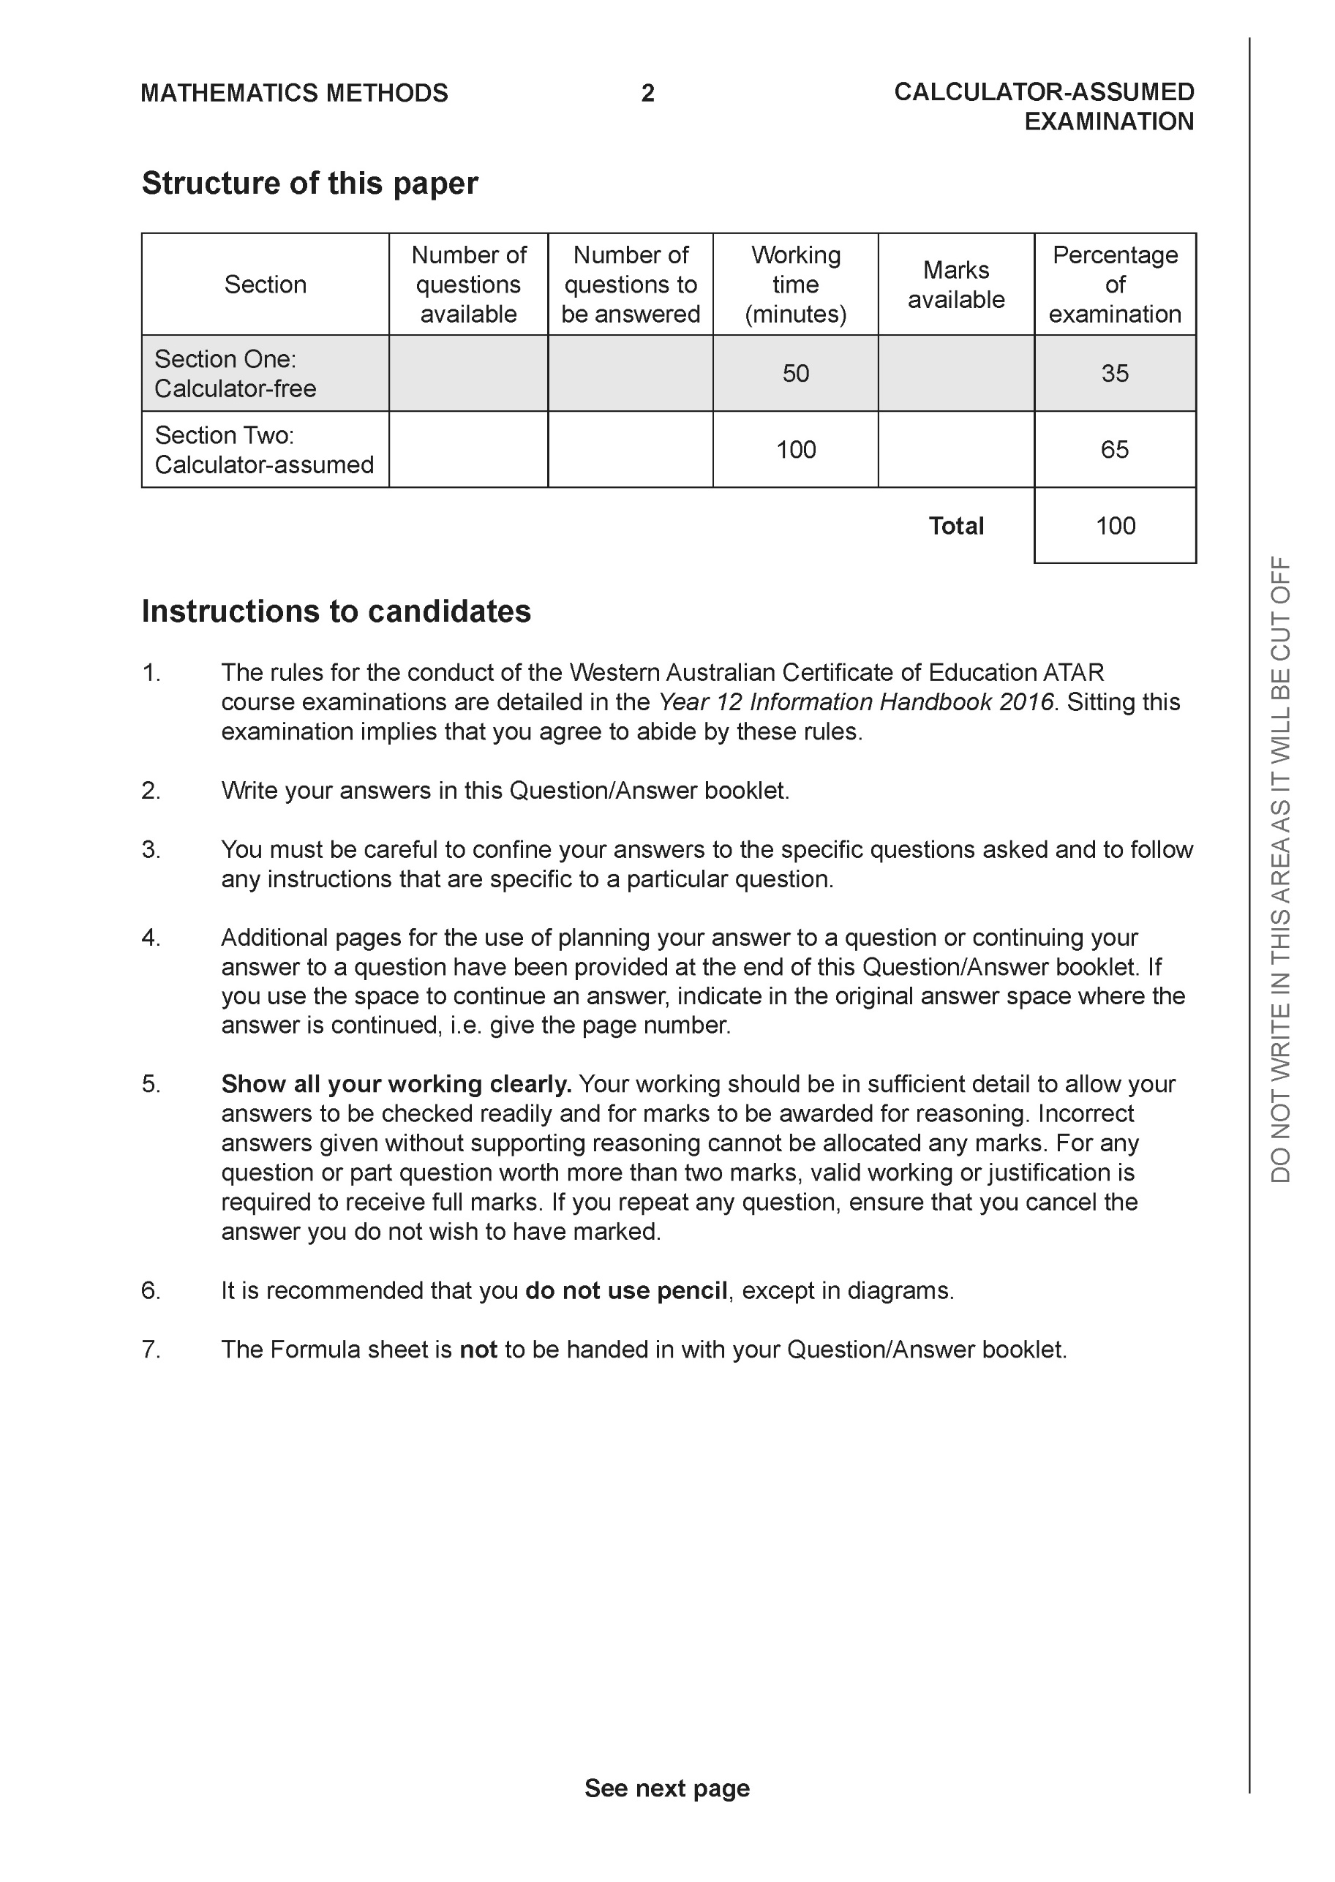

Section Two: Calculator-assumed (95 Marks)

This section has 13 questions. Answer all questions. Write your answers in the spaces provided.

Spare pages are included at the end of this booklet. They can be used for planning your responses and/or as additional space if required to continue an answer.
● Planning: If you use the spare pages for planning, indicate this clearly at the top of the page.
● Continuing an answer: If you need to use the space to continue an answer, indicate in the original answer space where the answer is continued, i.e. give the page number. Fill in the number of the question that you are continuing to answer at the top of the page.

Working time: 100 minutes.

Question 9 (4 marks)

Using vectors and the vector property , prove the following inequality
Solution
Specific behaviours
uses dot product to find magnitude of sum of vectors
expands dot product and collects like terms
uses upper limit for dot product of the two vectors to generate inequality
uses difference of two squares to prove inequality

Question 10 (9 marks)

Consider the following system of linear equations where are constants.

Determine the values of :
(a) for which there is a unique solution (4 marks)

Solution

Unique

Specific behaviours
eliminates one variable from two equations
eliminates two variables from one equation
identifies all allowed values for m
states that all real values of p allowed

(b) for which there are infinite solutions. (3 marks)

Solution
Specific behaviours
shows that a line of zeros required or gives reasoning
states value for m
states value for p

(c) for which there are no solutions. (2 marks)
Solution
Specific behaviours
states value of m
states all allowed values of p

Question 11 (4 marks)
Consider the plane as shown below.

Determine the distance of point P from the plane to two decimal places.

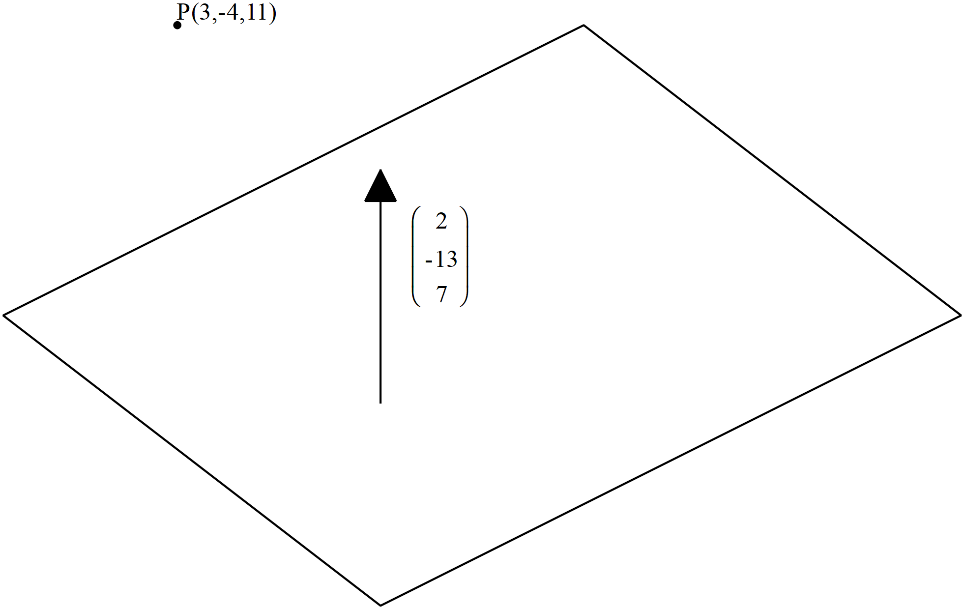
Solution
Line through P and parallel to normal

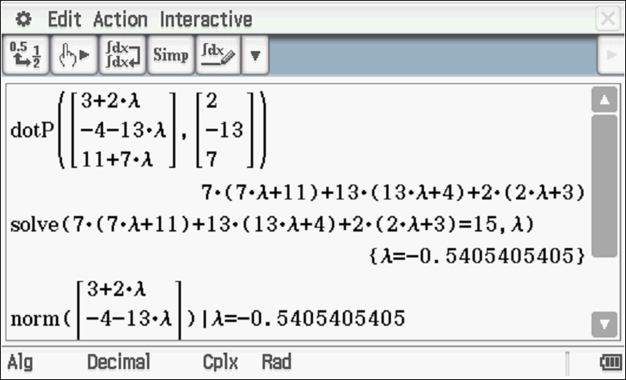

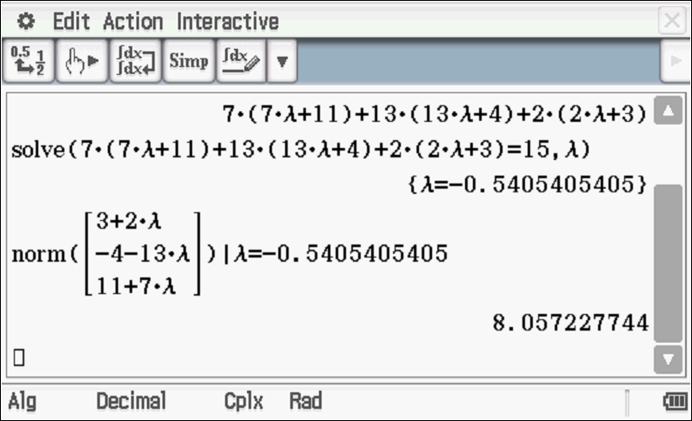

Specific behaviours
determines vector equation of line through P
subs vector eqn of line into plane and uses dot product equaling 15
solves for parameter
determines distance (no need to round to 2 dp)
OR
determines any point on plane B
determines vector PB
dots this vector with unit normal
determines distance

Question 12 (4 marks)

Given that use cross product to determine the distance of point P from the line to one decimal place.

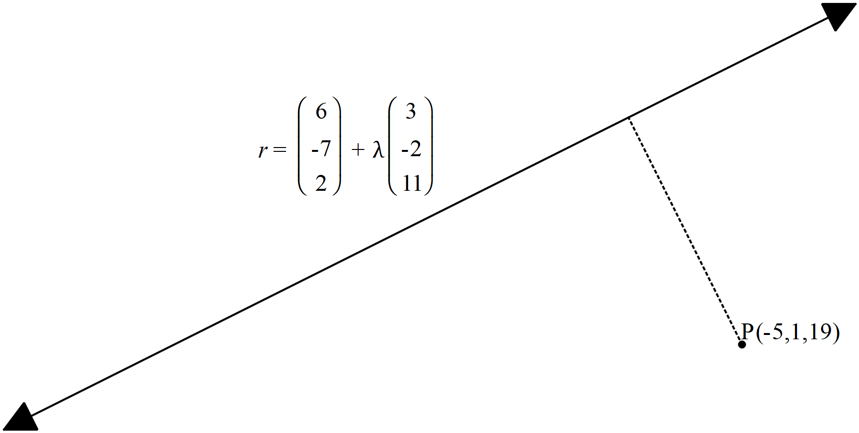
Solution

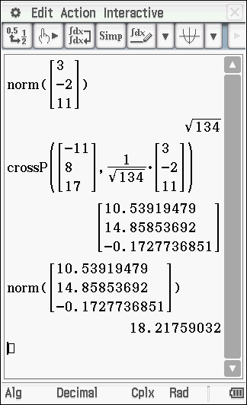

Specific behaviours
determines vector AP
uses unit vector parallel to line
uses cross product of the above vectors
determines magnitude of cross product ( no need to round to one dp)

Question 13 (4 marks)

The three vertices of a triangle have position vectors . Given that
Show that the area of the triangle is given by

Solution
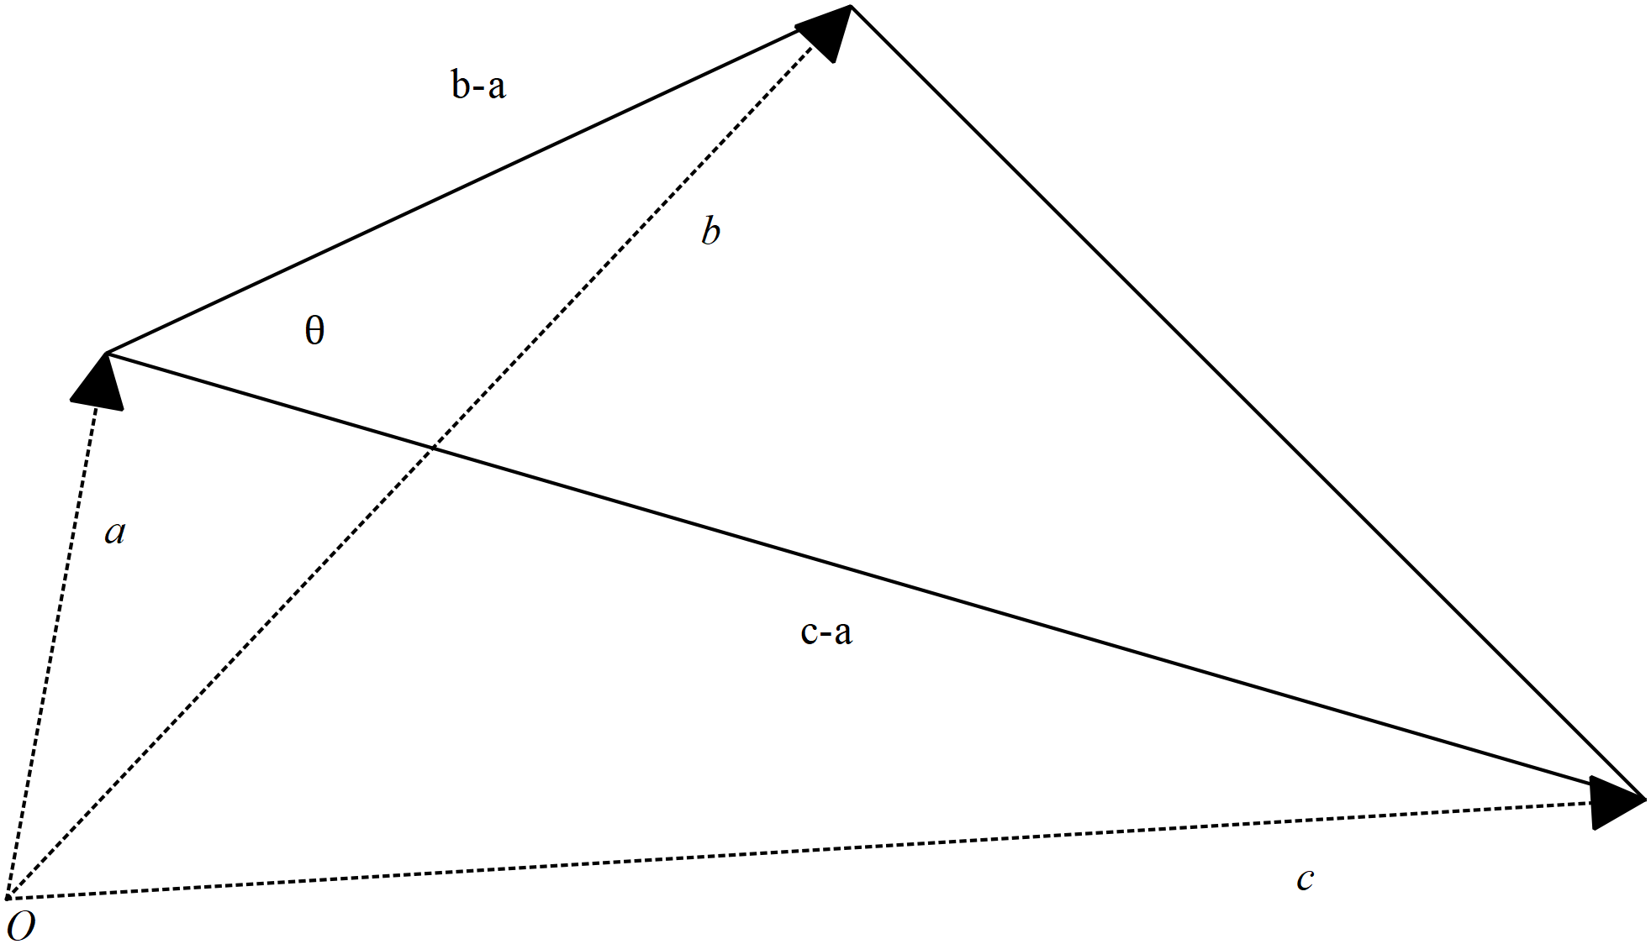

Specific behaviours
uses area formula for triangle using adjacent sides and included angle
uses difference vectors and magnitude of cross product to determine this area
uses that a vector crossed itself is zero and changing order negates sign
summarises to show required result

Question 14 (6 marks)

Consider the polynomial where are real constants. Determine the values of given the following information for
is a factor of .
When is divided by there is a remainder of 165
and

Solution
Conjugate of is also a root

Specific behaviours
uses conjugate to determine new factor
uses factor of x-2
subs x=0 y=32
subs x=1 y=165
solves for all linear factors
expands factors to determine coefficients

575=(x+2)5(23)

Question 15 (9 marks)

At noon a rocket is launched from position km with a velocity of km/h.
Two hours later a second rocket is launched from position km with a velocity of km/h.
Assume that both rockets move with constant velocity at all times and that the rockets
do not collide.

(a) Determine the distance between the rockets at 2:30pm that day to one decimal place
(3 marks)

Solution
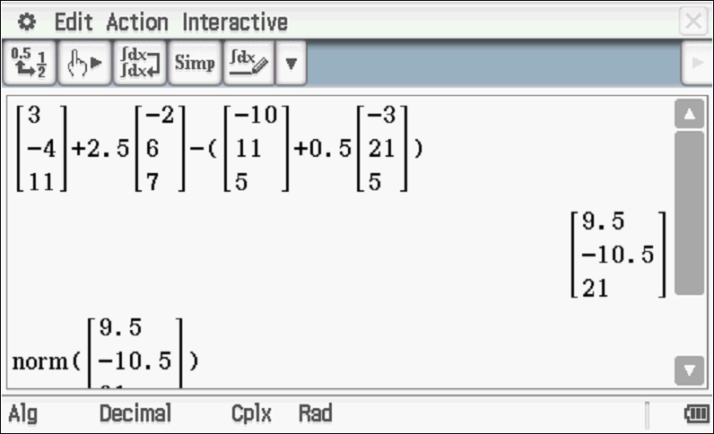
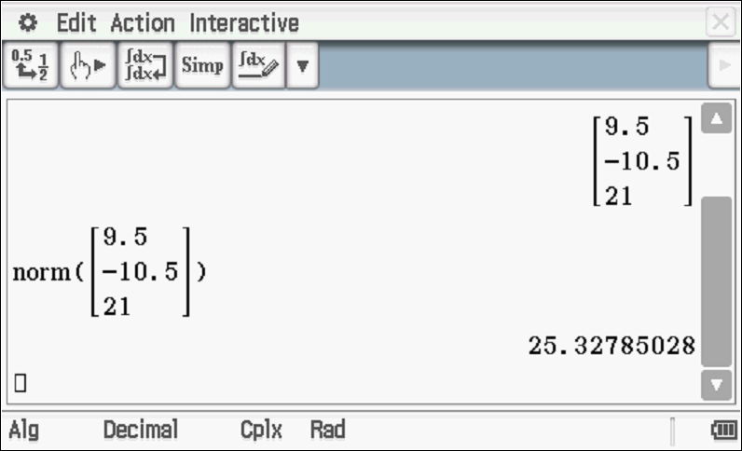

Specific behaviours
Uses vector equations for paths of both rockets
uses appropriate time values
determines distance apart ( no need to round to 1 dp)

(b) Determine the times that the distance between the rockets is less than 50 km.
(4 marks)

Solution
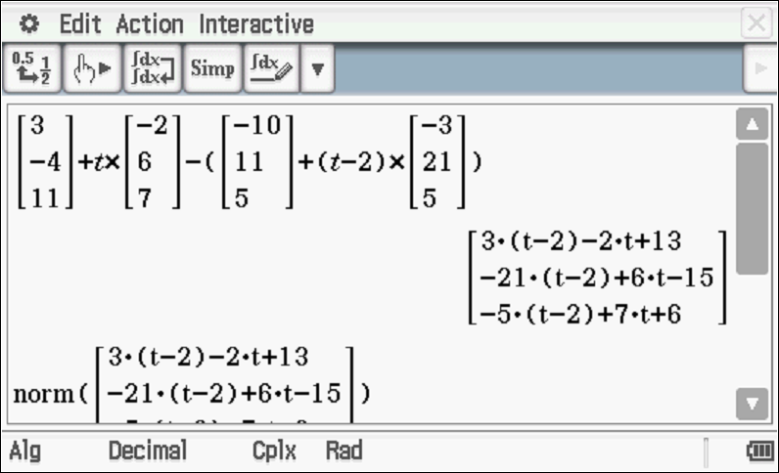
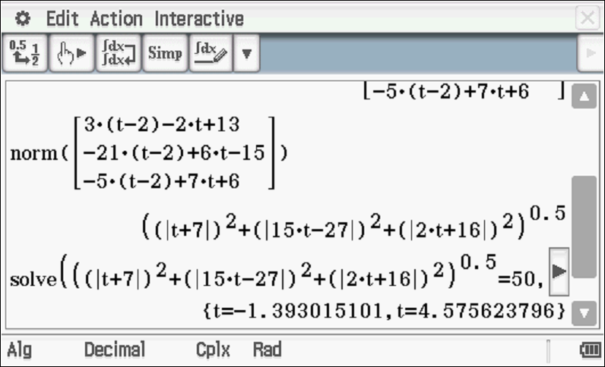

Specific behaviours
determines vector equation for rocket in terms of t
determines vector equation of second rocket for t-2
determines expression for magnitude of separation in terms of t and equates to 50k
identifies approx (no need to round)

(c) Determine the distance of closest approach and the time that this occurs. (2 marks)

Solution
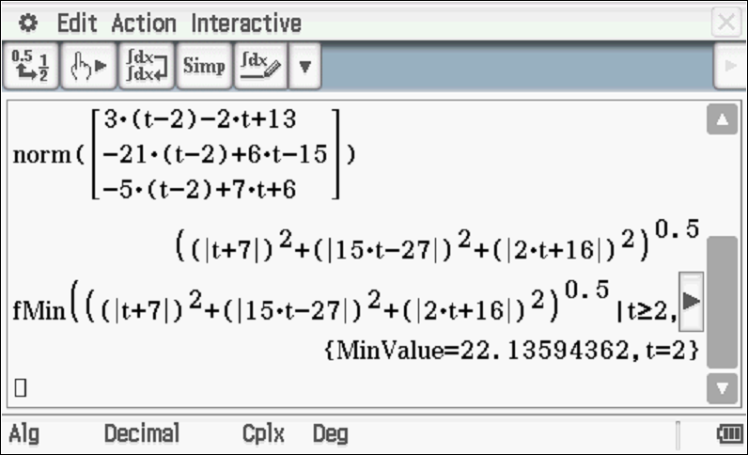

Closest distance of 22.14 km at t=2 hours at time 2 pm
Specific behaviours
determines minimum value of separation magnitude and states distance
gives time that is within one minute of correct answer

Question 16 (9 marks)

Consider the complex numbers drawn in the complex plane below.

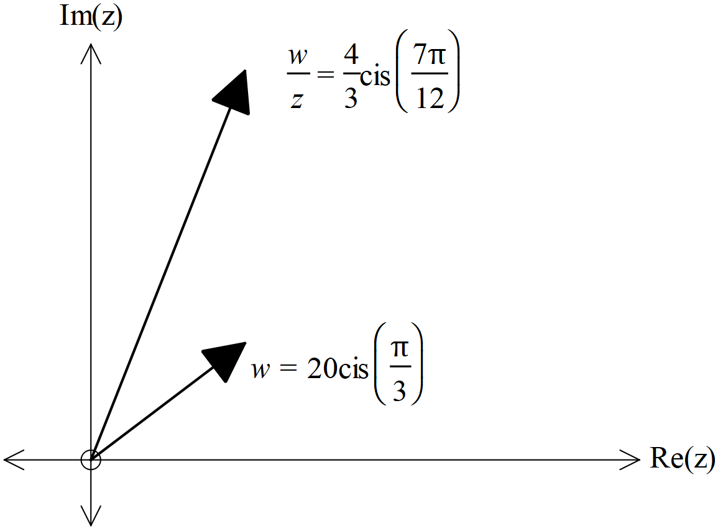
(a) Determine the exact value of in the form of (3 marks)

Solution
Specific behaviours
determines modulus for z
determines Arg for z
express z in cartesian form (No need to rationalize denominator)

Consider the equation
where and

(b) Represent the above equation as a triangle in the complex plane below (3 marks)
Solution
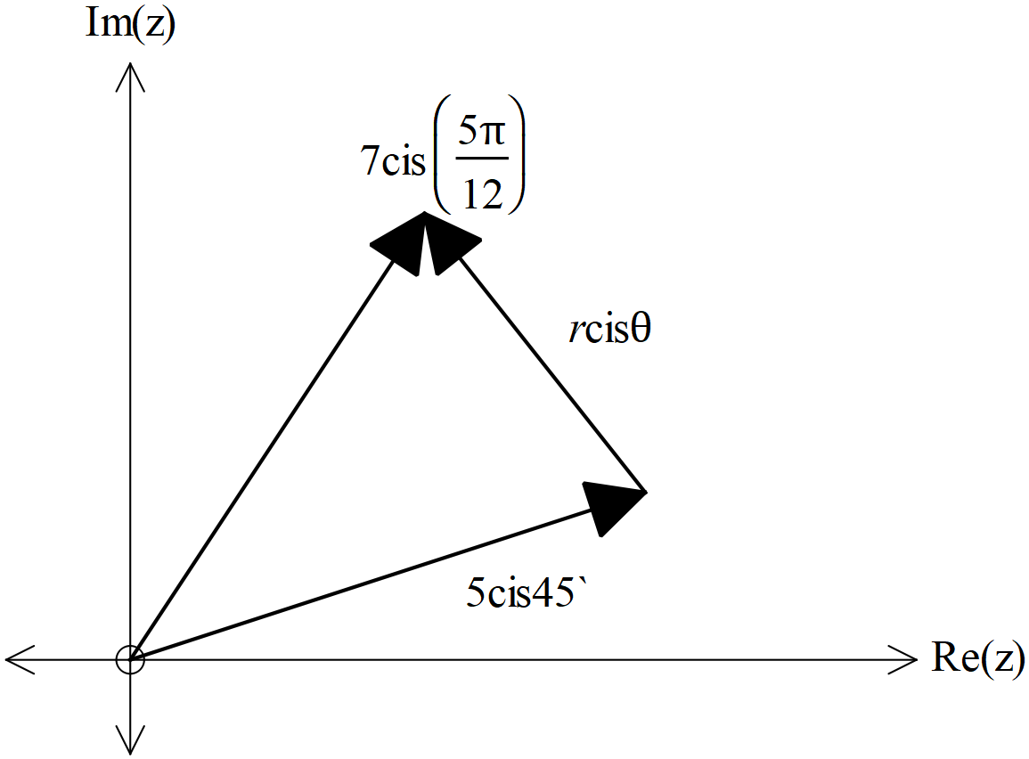

Specific behaviours
expresses the first complex number as 5 cis45 on triangle
shows two complex numbers adding as vectors to give LHS
third side in triangle represents unknown complex number

Cont-

(c) Hence or otherwise solve for to one decimal place. (3 marks)

Solution
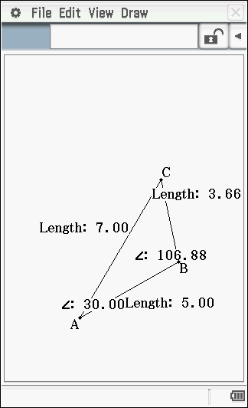

Specific behaviours
solves for r using geometry or cosine rule
solves another angle in triangle
determines Principal Argument in radians
(No need to round to 1 dp)

Question 17 (9 marks)

Consider a sphere with centre and radius of units.

(a) Write down the vector equation for this sphere (2 marks)

Solution
Specific behaviours
uses difference of r from centre
equates difference to radius

Consider a line parallel to vector and containing the point
where is a constant.

(b) Write down the vector equation of the line in terms of . (2 marks)

Solution
Specific behaviours
uses parameter
states correct vector equation

(c) Determine the possible values of , to 2 decimal places, if the line is a tangent to the sphere..
(5 marks)

Solution
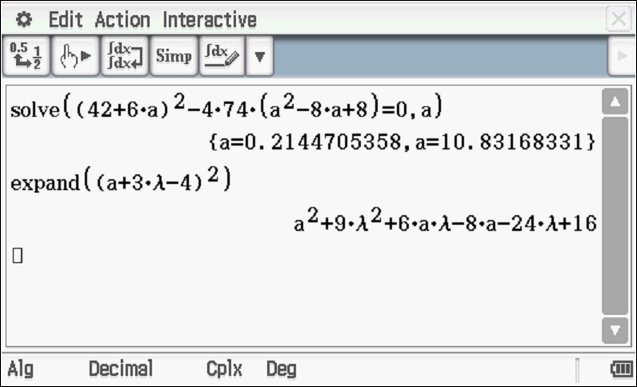

Specific behaviours
subs r from line into vector eqn of sphere
obtains an equation in terms of a and paremeter
expands and adds like terms to give a quadratic equation where the
quadratic formula maybe used.
obtains expression for discriminant and equates to zero solving for a
gives two values for a (no need to give to 2 dp)

Question 18 (11 marks)

A particle moves with acceleration at time seconds. The initial velocity is and initial displacement of .

(a) Determine the time(s),, that the particle is travelling parallel to the y axis.
(4 marks)

Solution
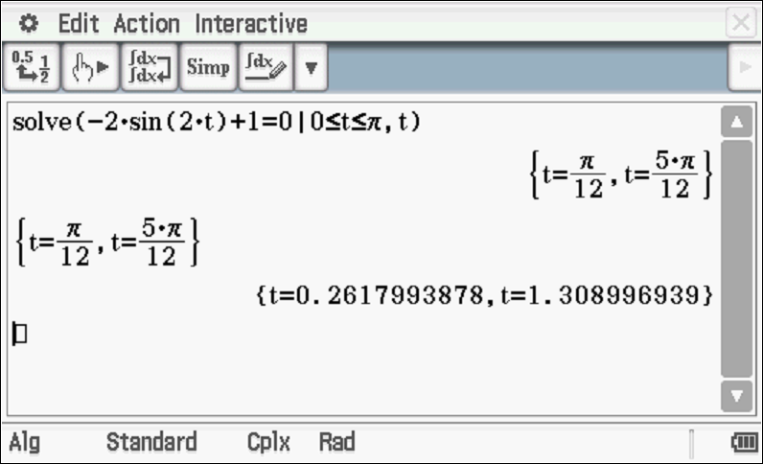

Specific behaviours
anti-differentiates to determine velocity
determines vector constant
equates i component of velocity to zero
solves for t in required interval (approx.)

(b) Determine the first two times that the particle crosses the y axis. (4 marks)

Solution

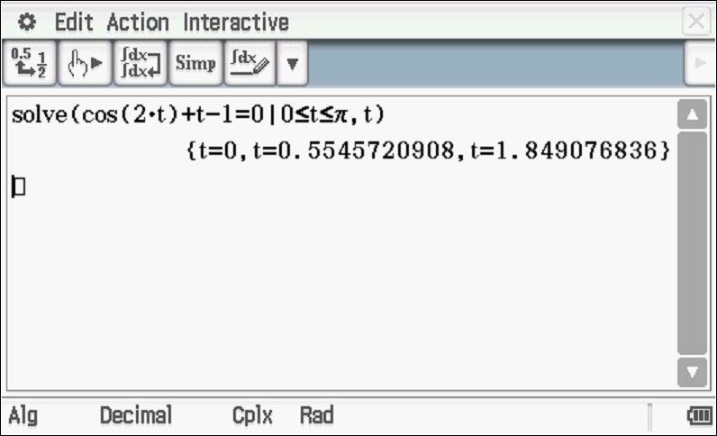

Specific behaviours
anti-differentiates to determine position vector
determines vector constant
equates i component to zero
solves for t giving first two positive values only (approx.)

(c) Determine the cartesian equation of the path of a new particle with the following position vector (3 marks)

Solution
Specific behaviours
obtains sint in terms of x
uses double angle formula to rearrange y expression
obtains a cartesian equation (unsimplified)

Question 19 (9 marks)

Consider the function where and
are positive constants with

(a) Given that the inverse function does exist obtain an expression for
in terms of (3 marks)

Solution
Specific behaviours
swaps x and y
uses quadratic formula or completing the square to solve for inverse
uses negative as

(b) Given that there is only one point where determine the x value
in terms of (3 marks)
i
Solution
Specific behaviours
equates f(x) to x
solves using quadratic formula or completing the square to solve for x
uses negative sign to give one answer for x

(c) Given that and ,
determine the function in terms of (3 marks)
Solution
Specific behaviours
expresses x in terms of y for h(x)
subs into composite to give expression in terms of y only
states g(x) in terms of x only

Question 20 (11 marks)

Consider drawn below, where each face is a parallelogram. Let , and with perpendicular to plane containing vectors .

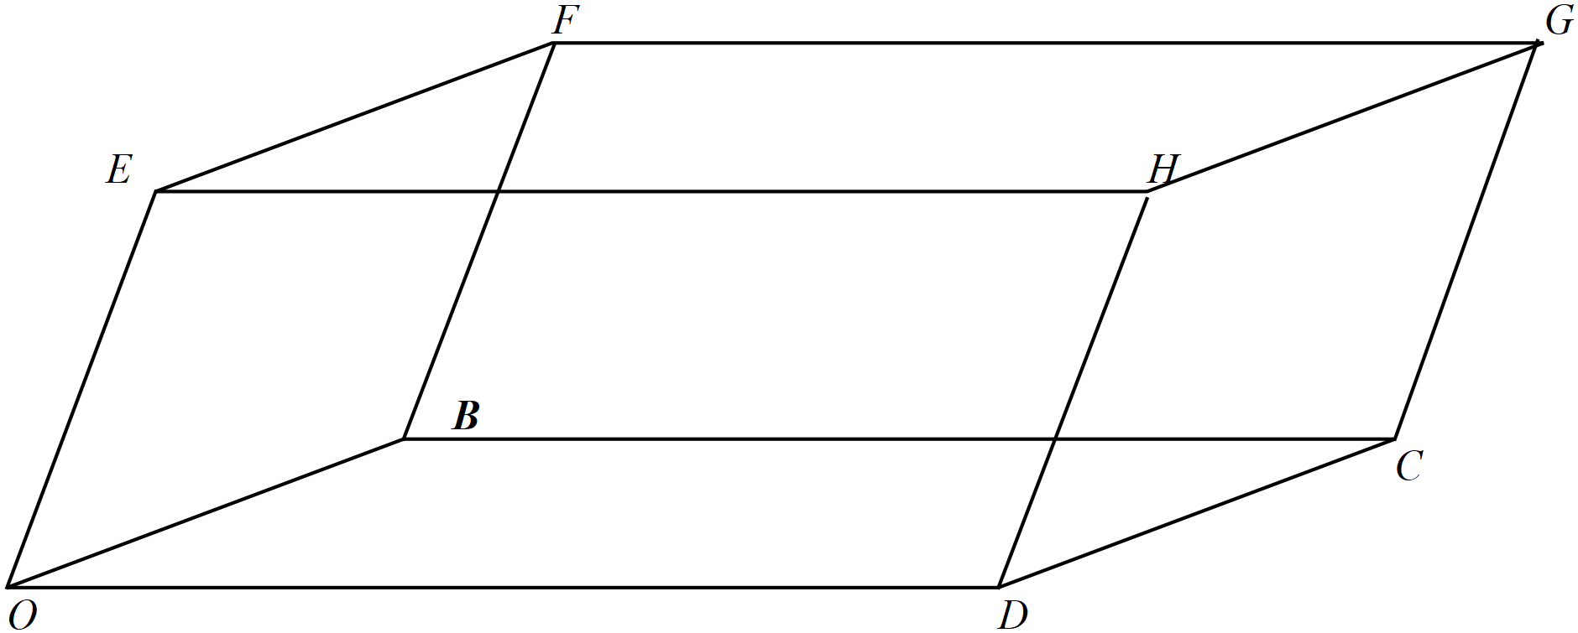

(a) Express each of the vectors in terms of
(4 marks)

Solution
Specific behaviours
(one mark for each vector)

(b) Express in terms of (4 marks)

Solution
Specific behaviours
dots vector with itself to obtain magnitude squared
recognizes that b.e=0=b.d
obtains two correct expressions
obtains all four correct expressions

Cont-
(c) Hence show that
(3 marks)

Solution
Specific behaviours
shows that d.e terms all cancel
shows that each magnitude occurs four times in sum
shows that LHS=RHS
(Maximum of one mark follow through if expressions in part b are incorrect)

Question 21 (6 marks)
Consider the region defined by in the complex plane.

(a) Sketch the region on the axes below. (3 marks)

Solution
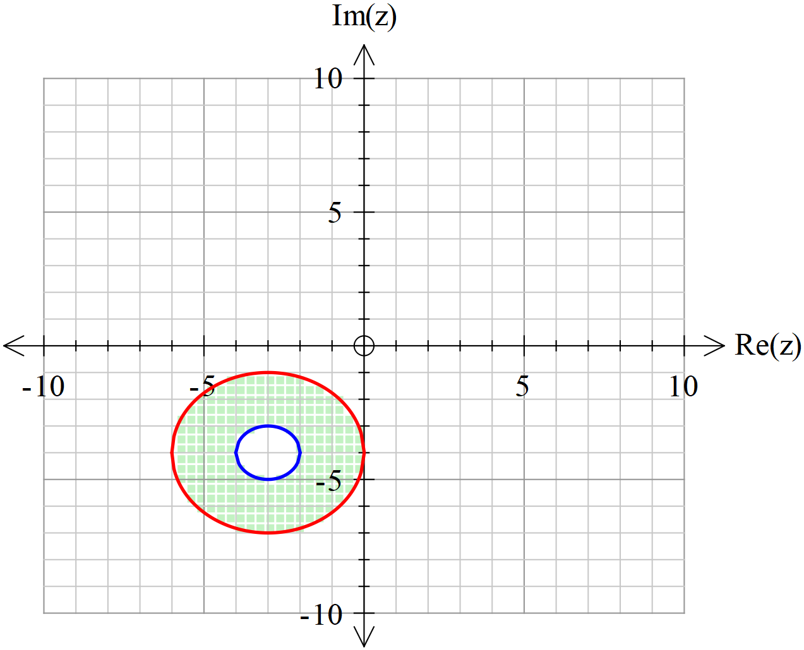

Specific behaviours
centre of both circles at -3-4i
radii of both circles correct
area between circles shaded including circles

(b) Given that , determine the minimum value of
In the region in (a).(Give to two decimal places) (3 marks)

Solution
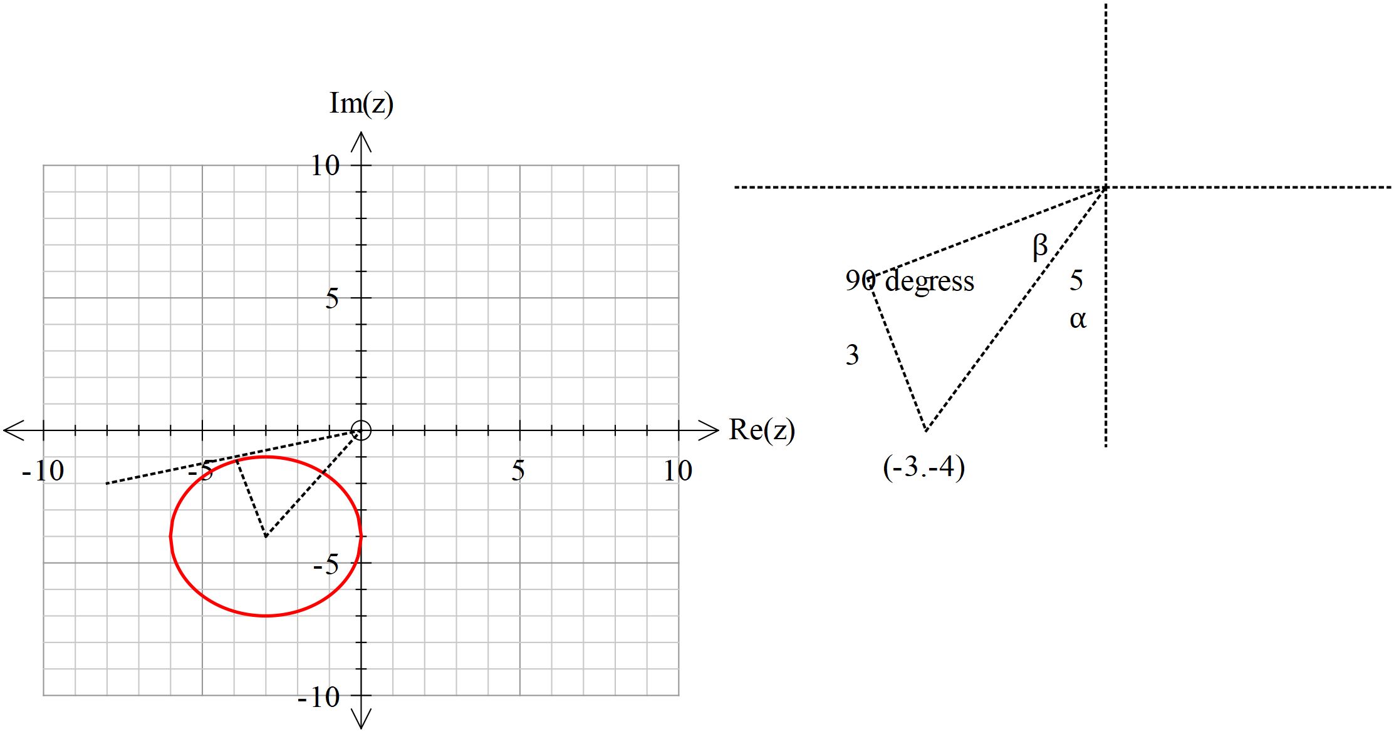

Specific behaviours
uses tangent at top of circle through origin
determines both angles in diagram above
determines minimum argument in allowed interval (Principal)

Additional working space
Question number:

Additional working space
Question number:

Additional working space
Question number:

Acknowledgements

